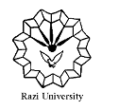
Razi University
Faculty of Chemistry
Department of Applied Chemistry
M.S.C Seminar

Application of nanoparticles in wound healing

Supervisor:
Dr. Marzeih Sadeghi

Presented by:
Hadis Angazi

Thursday:
2021 March 18
2:00 PM

